**SOFTWARE REQUIREMENT SPECIFICATION**

**DOCUMENT**

**CALCULATOR SYSTEM**

**Version:** Version 1.0

**ABSTRACT**

This document is intended to be the SRS for developing **CALCULATOR SYSTEM**

|  |  |  |  |
| --- | --- | --- | --- |
| **Project Title** | **CALCULATOR SYSTEM** | | |
| **Lead Institution** | **THE INTERNATIONAL SCHOOL - DUY TAN UNIVERSITY** | | |
| **Project Mentor** | **Mr. Nguyen Dang Quang Huy** | | |
| **Team Name** | **Team 2** | | |
| **Team Members** | **Bui Thanh Nghia** | | |
| **Tran Quang Hieu** | | |
| **Huynh Duc Huy** | | |
| **Vo Hung Cuong** | | |
| **Nguyen Trung Kien** | | |
| **Start Date** | Jan 20, 2024 | **End Date** | Jan 27,2024 |

**PROPRIETARY INFORMATION**: The information contained in this document is the property of **TEAM 2**. Except as specifically authorized in writing by **TEAM 2**, the holder of this document shall keep all information contained herein confidential and shall protect same in whole or in part from disclosure and dissemination to all third parties

**Table of Contents**

Revision History 3

1. Introduction 6

1.1. Purpose 6

1.2. Intended Audience and Reading Suggestions 6

1.3. References 6

2. Project Overview 6

2.1. Project Description 6

2.2. Business Need 7

2.3. Project Analyst 7

2.3.1. Business Function Diagram 7

2.3.2. System Context Diagram 8

2.4. Software Requirement Specification 8

2.4.1. High level Functional Requirement (FR) 8

2.4.2. Stakeholders 9

2.4.3. Use case 10

2.4.4. List of use case 10

UC 01: Addition 10

UC 02: Subtraction 12

UC 03: Multiplication 13

UC 04: Division 14

UC 05: Division with remainder 16

2.4.6 . Activity Diagrams 17

Addition 17

Subtraction 17

Multiplication 18

Division 19

Division with remainder 19

Appendix A: Glossary 20

# Revision History

|  |  |  |  |  |
| --- | --- | --- | --- | --- |
| **Date** | **Change Iterm** | **Description** | **by** | **Version** |
| **20/1/2024** | Get requests from customers | After preparing the questions about the request and received the request from the customer | Tran Quang Hieu | Version 1.0 |
| **20/1/2024** | Start team meeting | Meet and refer to a number of training points, read through the training points and focus on project implementation, the team can fully understand the system requirements to create | Tran Quang Hieu, Vo Hung Cuong, Huynh Duc Huy, Bui Thanh Nghia, Nguyen Trung Kien | Version 1.0 |
| **21/1/2024** | Job analysis | Through specific requirements, analysis, clearly speaking, the leader needs to prepare in advance for the members. | Tran Quang Hieu, Huynh Duc Huy | Version 1.0 |
| **21/1/2024** | Share the work | Get BFD, contextual diagram, DFD level 1, DFD level 2,  The mandatory rules of the project | Tran Quang Hieu, Vo Hung Cuong, Huynh Duc Huy, Bui Thanh Nghia, Nguyen Trung Kien | Version 1.0 |
| **23/1/2024** | Mr. Huy corrected | Fix BFD, DFD, USE CASE, font size, font pattern, context diagram, more clearly about the missing and suggest some important things | Tran Quang Hieu, Huynh Duc Huy | Version 1.0 |
| **23/1/2024** | Editing group | BFD, DFD, USE CASE, Context Diagram, font size, font | Tran Quang Hieu, Vo Hung Cuong, Huynh Duc Huy, Bui Thanh Nghia, Nguyen Trung Kien | Version 1.0 |
| **24/1/2024** | Complete DFD, System Context Diagram | DFD 1 and 2, System Context Diagram | Tran Quang Hieu, Vo Hung Cuong, Huynh Duc Huy, Bui Thanh Nghia, Nguyen Trung Kien | Version 1.0 |
|  |  |  |  |  |

# Introduction

## Purpose

This documentation describes a calculator system including all needed information and feature materials in detail for implementation. The purposes of this document are as below:

* To support the project manager having an overview of the system as well as doing project estimation
* To describe the architectural drivers and use cases in detail. Based on this document, architect analysts and designers will be able to implement the system easily.
* To support testers (QC) writing acceptance test and test plan.

## Intended Audience and Reading Suggestions

|  |  |
| --- | --- |
| Intended Audience | Reading Suggestions |
| Project manager | High level functional requirement, business constraints for estimation |
| Architect analyst and designer | Overall description and user cases to architect and design the system |
| Quality control | Overall description and user cases to make test plan and write acceptance test |

## References

# Project Overview

## Project Description

The advent of Information Technology has profoundly transformed human existence, ushering in unprecedented convenience through a myriad of innovative applications. As we navigate the swiftly evolving landscape of Information Technology, an array of tools, technologies, and systems have emerged, shaping a new era of possibilities and advancements.

This project focuses on creating a Calculator System for Streamline Calculations Inc., aiming to enhance the efficiency and user-friendliness of mathematical computations. The Calculator System facilitates seamless automation of various mathematical processes. The primary objectives of this project include delivering a user-friendly interface, ensuring data security, optimizing operational efficiency, and minimizing the need for manual intervention in mathematical calculations at Streamline Calculations Inc.

## Business Need

The Calculator System boasts several key advantages:

- Facilitates professional tasks for mathematicians, streamlining calculations and improving efficiency.

- Simplifies the process of searching for specific functions, enabling swift access for users.

- The system meets all specified requirements from Streamline Calculations Inc., with the capacity for maintenance and upgrades.

- User-friendly interface ensures ease of operation.

## Project Analyst

### Business Function Diagram

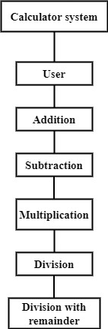

### System Context Diagram

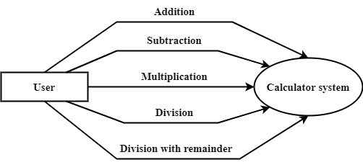

## Software Requirement Specification

### High level Functional Requirement (FR)

|  |  |  |
| --- | --- | --- |
| **FR1.1** | **Title** | **Addition** |
| User | Actor uses this Use Case to demonstrate additional calculation to the system. |
| Description | The user selects the addition function on the main interface, then the system opens an additional calculation interface, awaiting user input for the number 1 and number 2 to be calculated. The users enter number 1 and number 2 to be added into the provided fields on the interface. The system validates the input data for accuracy and validity. Then, it displays the result on the interface and provides options for the user to clear calculation and do it again or exit the additional interface. |
| **FR1.2** | **Title** | **Subtraction** |
| User | Actor uses this Use Case to demonstrate subtraction calculation to the system. |
| Description | The user selects the addition function on the main interface, then the system opens a subtraction calculation interface, awaiting user input for the numbers to be calculated. The users enter number 1 and number 2 to be added into the provided fields on the interface. The system validates the input data for accuracy and validity. Then, it performs a subtraction calculation of 2 numbers and displays the result on the interface. Then, provides options for the user to clear calculation and do it again or exit the subtraction interface. |
| **FR1.3** | **Title** | **Multiplication** |
| User | Actor uses this Use Case to demonstrate multiplication calculation to the system. |
| Description | The user selects the addition function on the main interface, then the system opens a multiplication calculation interface, awaiting user input for the numbers to be calculated. The users enter number 1 and number 2 to be added into the provided fields on the interface. The system validates the input data for accuracy and validity. Then, it performs a multiplication calculation of 2 numbers and displays the result on the interface. Then, provides options for the user to clear calculation and do it again or exit the multiplication interface. |
| **FR1.4** | **Title** | **Division** |
| User | Actor uses this Use Case to demonstrate division calculation to the system. |
| Description | The user selects the addition function on the main interface, then the system opens a division calculation interface, awaiting user input for the numbers to be calculated. The users enter number 1 and number 2 to be added into the provided fields on the interface. The system validates the input data for accuracy and validity. Then, it performs a division calculation of 2 numbers and displays the result on the interface. Then, provides options for the user to clear calculation and do it again or exit the division interface. |
| **FR1.5** | **Title** | **Division with remainder** |
| User | Actor uses this Use Case to demonstrate division with remainder calculation to the system. |
| Description | The user selects the addition function on the main interface, then the system opens a division with remainder calculation interface, awaiting user input for the numbers to be calculated. The users enter number 1 and number 2 to be added into the provided fields on the interface. The system validates the input data for accuracy and validity. Then, it performs division with remainder calculation of 2 numbers and displays the result on the interface. Then, provides options for the user to clear calculation and do it again or exit the division with remainder interface. |

### Stakeholders

|  |  |
| --- | --- |
| **Stakeholder** | **Description** |
| User (Staff of Streamline Calculations Incorporated) | System user |

### Use case

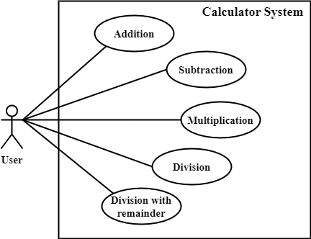

### List of use case

|  |  |  |
| --- | --- | --- |
| **Use case ID** | **Use case name** | **Functional Req.** |
| UC.01 | Addition | FR.1 |
| UC.02 | Subtraction | FR.2 |
| UC.03 | Multiplication | FR.3 |
| UC.04 | Division | FR.4 |
| UC.05 | Division with remainder | FR.5 |

**2.4.5.Use Case Specification**

##### UC 01: Addition

1. Use Case Diagram



1. Use Case Specification

|  |  |  |  |  |  |
| --- | --- | --- | --- | --- | --- |
| Use case ID | UC.01 | | | | |
| Use case name | **Addition** | | | | |
| Create by | Quang Hieu | | **Last updated by** | | Quang Hieu |
| Date created | January 21, 2024 | | **Date last updated** | | January 24, 2024 |
| Actor | Users of the system, including: Staff of Streamline Calculations Incorporated | | | | |
| Description | This use case shows the process followed by a user demonstrating addition calculation in the Calculation System. | | | | |
| Trigger | Click to “**Addition**” in navigator at home page | | | | |
| Pre-condition | None | | | | |
| Post-condition | If the use case is successful. The system opens a addition calculation interface. | | | | |
| Main Success Scenario: | **Step** | **Actor Action** | | **System Response** | |
| 1 | Click to “**Addition**” in navigator at main interface | | Redirect to Addition interface | |
| 2 | Fill out two data fields: number 1 and number 2 | |  | |
| 3 | Click to “**+**” button. | | The system will perform the calculation of addition two numbers, (data type of double or integer), then print the results to the screen. | |
| 4 | Click to “Clear” button if want to continue. | | The system will delete data of number 1, number 2 and results. Allows users to enter data and perform calculations. | |
| Alternative Scenario | **Step** | **Actor Action** | | **System Response** | |
| 1 | Click to “**Addition**” in navigator at main interface | | Redirect to Addition interface | |
| 2 | Fill out two data fields: number 1 and number 2 | |  | |
| 3 | Click to “+” button. | | The system will display an error message. User can enter again number 1 and number 2. | |
| Exception | **Step** | **Actor Action** | | **System Response** | |
| 1 | Input data is invalid | | Show message: "Error! The value you enter must be a real number." | |
| Priority | High | | | | |
| Business rule | N/A | | | | |
| Description: | This function allows users to perform addition of two numbers. By entering two numbers of integer or decimal type. You are not allowed to enter other characters. If you do, you will receive an error message. Also allows users to re-enter if desired. | | | | |

##### UC 02: Subtraction

1. Use Case Diagram



1. Use Case Specification

|  |  |  |  |  |  |
| --- | --- | --- | --- | --- | --- |
| Use case ID | UC.02 | | | | |
| Use case name | **Subtraction** | | | | |
| Create by | Quang Hieu | | **Last updated by** | | Quang Hieu |
| Date created | January 21, 2024 | | **Date last updated** | | January 24, 2024 |
| Actor | Users of the system, including: Staff of Streamline Calculations Incorporated | | | | |
| Description | This use case shows the process followed by a user demonstrate subtraction calculation in the Calculation System. | | | | |
| Trigger | Click to “**Subtraction**” in navigator at home page | | | | |
| Pre-condition | None | | | | |
| Post-condition | If the use case is successful. The system opens a subtraction calculation interface. | | | | |
| Main Success Scenario: | **Step** | **Actor Action** | | **System Response** | |
| 1 | Click to “**Subtraction**” in navigator at main interface | | Redirect to subtraction interface | |
| 2 | Fill out two data fields: number 1 and number 2 | |  | |
| 3 | Click to “**-**” button. | | The system will perform the calculation of subtraction two numbers, (data type of double or integer), then print the results to the screen. | |
| 4 | Click to “Clear” button if want to continue. | | The system will delete data of number 1, number 2 and results. Allows users to enter data and perform calculations. | |
| Alternative Scenario | **Step** | **Actor Action** | | **System Response** | |
| 1 | Click to “**Subtraction**” in navigator at main interface | | Redirect to subtraction interface | |
| 2 | Fill out two data fields: number 1 and number 2 | |  | |
| 3 | Click to “**-**” button. | | The system will display an error message. User can enter again number 1 and number 2. | |
| Exception | **Step** | **Actor Action** | | **System Response** | |
| 1 | Input data is invalid | | Show message: "Error! The value you enter must be a real number." | |
| Priority | High | | | | |
| Business rule | N/A | | | | |
| Description: | This function allows users to perform subtraction of two numbers. By entering two numbers of integer or decimal type. You are not allowed to enter other characters. If you do, you will receive an error message. Also allows users to re-enter if desired. | | | | |

##### UC 03: Multiplication

1. Use Case Diagram



1. Use Case Specification

|  |  |  |  |  |  |
| --- | --- | --- | --- | --- | --- |
| Use case ID | UC.03 | | | | |
| Use case name | **Multiplication** | | | | |
| Create by | Quang Hieu | | **Last updated by** | | Quang Hieu |
| Date created | January 21, 2024 | | **Date last updated** | | January 24, 2024 |
| Actor | Users of the system, including: Staff of Streamline Calculations Incorporated | | | | |
| Description | This use case shows the process followed by a user demonstrate multiplication calculation in the Calculation System. | | | | |
| Trigger | Click to “**Multiplication**” in navigator at home page | | | | |
| Pre-condition | None | | | | |
| Post-condition | If the use case is successful. The system opens a multiplication calculation interface. | | | | |
| Main Success Scenario: | **Step** | **Actor Action** | | **System Response** | |
| 1 | Click to “**Multiplication**” in navigator at main interface | | Redirect to multiplication interface | |
| 2 | Fill out two data fields: number 1 and number 2 | |  | |
| 3 | Click to “**\***” button. | | The system will perform the calculation of multiplication two numbers, (data type of double or integer), then print the results to the screen. | |
| 4 | Click to “Clear” button if want to continue. | | The system will delete data of number 1, number 2 and results. Allows users to enter data and perform calculations. | |
| Alternative Scenario | **Step** | **Actor Action** | | **System Response** | |
| 1 | Click to “**Multiplication**” in navigator at main interface | | Redirect to Addition interface | |
| 2 | Fill out two data fields: number 1 and number 2 | |  | |
| 3 | Click to “**\***” button. | | The system will display an error message. User can enter again number 1 and number 2. | |
| Exception | **Step** | **Actor Action** | | **System Response** | |
| 1 | Input data is invalid | | Show message: "Error! The value you enter must be a real number." | |
| Priority | High | | | | |
| Business rule | N/A | | | | |
| Description: | This function allows users to perform multiplication of two numbers. By entering two numbers of integer or decimal type. You are not allowed to enter other characters. If you do, you will receive an error message. Also allows users to re-enter if desired. | | | | |

##### UC 04: Division

1. Use Case Diagram



1. Use Case Specification

|  |  |  |  |  |  |
| --- | --- | --- | --- | --- | --- |
| Use case ID | UC.04 | | | | |
| Use case name | **Division** | | | | |
| Create by | Huynh Duc Huy | | **Last updated by** | | Huynh Duc Huy |
| Date created | January 21, 2024 | | **Date last updated** | | January 24, 2024 |
| Actor | Users of the system, including: Staff of Streamline Calculations Incorporated | | | | |
| Description | This use case shows the process followed by a user demonstrate division calculation in the Calculation System. | | | | |
| Trigger | Click to “**Division**” in navigator at home page | | | | |
| Pre-condition | None | | | | |
| Post-condition | If the use case is successful. The system opens a division calculation interface. | | | | |
| Main Success Scenario: | **Step** | **Actor Action** | | **System Response** | |
| 1 | Click to “**Division**” in navigator at main interface | | Redirect to division interface | |
| 2 | Fill out two data fields: number 1 and number 2 | |  | |
| 3 | Click to “**/**” button. | | The system will perform the calculation of division two numbers, (data type of double or integer), then print the results to the screen. | |
| 4 | Click to “Clear” button if want to continue. | | The system will delete data of number 1, number 2 and results. Allows users to enter data and perform calculations. | |
| Alternative Scenario | **Step** | **Actor Action** | | **System Response** | |
| 1 | Click to “**/**” in navigator at main interface | | Redirect to division interface | |
| 2 | Fill out two data fields: number 1 and number 2 | |  | |
| 3 | Click to “**/**” button. | | The system will display an error message. User can enter again number 1 and number 2. | |
| Exception | **Step** | **Actor Action** | | **System Response** | |
| 1 | * Input data is invalid * Divisor has value equal to 0. | | * Show message: "Error! The value you enter must be a real number." * “Error, divisor must be different from 0.” | |
| Priority | High | | | | |
| Business rule | N/A | | | | |
| Description: | This function allows users to perform division of two numbers. By entering two numbers of integer or decimal type. You are not allowed to enter other characters or number 2 has value equal to 0. If you do, you will receive an error message. Also allows users to re-enter if desired. | | | | |

##### UC 05: Division with remainder

1. Use Case Diagram



1. Use Case Specification

|  |  |  |  |  |  |
| --- | --- | --- | --- | --- | --- |
| Use case ID | UC.05 | | | | |
| Use case name | **Division with remainder** | | | | |
| Create by | Huynh Duc Huy | | Create by | | Huynh Duc Huy |
| Date created | January 21, 2024 | | Date created | | January 24, 2024 |
| Actor | Users of the system, including: Staff of Streamline Calculations Incorporated | | | | |
| Description | This use case shows the process followed by a user demonstrate division with remainder calculation in the Calculation System. | | | | |
| Trigger | Click to “**Division with remainder**” in navigator at home page | | | | |
| Pre-condition | None | | | | |
| Post-condition | If the use case is successful. The system opens a division with remainder calculation interface. | | | | |
| Main Success Scenario: | **Step** | **Actor Action** | | **System Response** | |
| 1 | Click to “**Division with remainder**” in navigator at main interface | | Redirect to division with remainder interface | |
| 2 | Fill out two data fields: number 1 and number 2 | |  | |
| 3 | Click to “**%r**” button. | | The system will perform the calculation of division with remainder two numbers, (data type of double or integer), then print the results to the screen. | |
| 4 | Click to “Clear” button if want to continue. | | The system will delete data of number 1, number 2 and results. Allows users to enter data and perform calculations. | |
| Alternative Scenario | **Step** | **Actor Action** | | **System Response** | |
| 1 | Click to “**Division with remainder**” in navigator at main interface | | Redirect to division with remainder interface | |
| 2 | Fill out two data fields: number 1 and number 2 | |  | |
| 3 | Click to “**%**” button. | | The system will display an error message. User can enter again number 1 and number 2. | |
| Exception | **Step** | **Actor Action** | | **System Response** | |
| 1 | * Input data is invalid * Divisor has value equal to 0. | | * Show message: "Error! The value you enter must be a real number." * “Error, divisor must be different from 0.” | |
| Priority | High | | | | |
| Business rule | N/A | | | | |
| Description: | This function allows users to perform division with remainder of two numbers. By entering two numbers of integer or decimal type. You are not allowed to enter other characters or number 2 has value equal to 0. If you do, you will receive an error message. Also allows users to re-enter if desired. | | | | |

## 2.4.6 . Activity Diagrams

## Addition

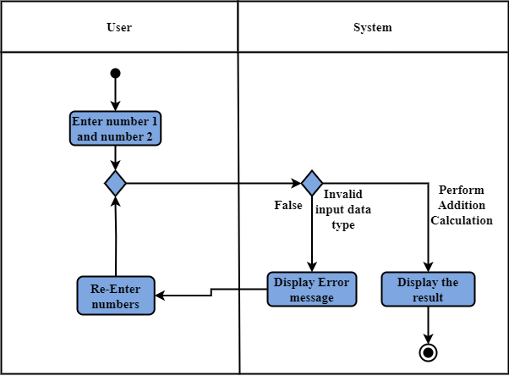

## Subtraction

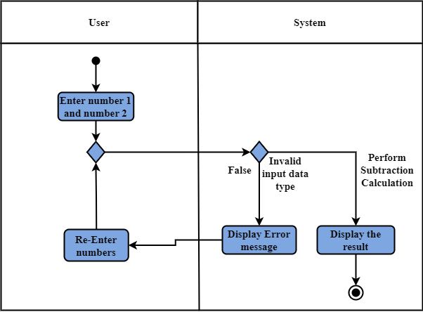

## Multiplication

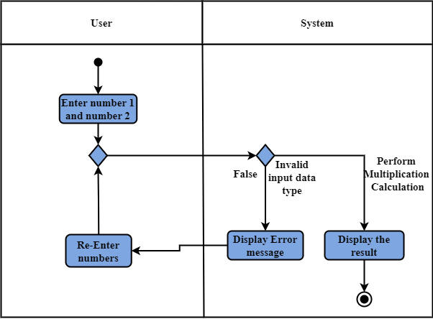

## Division

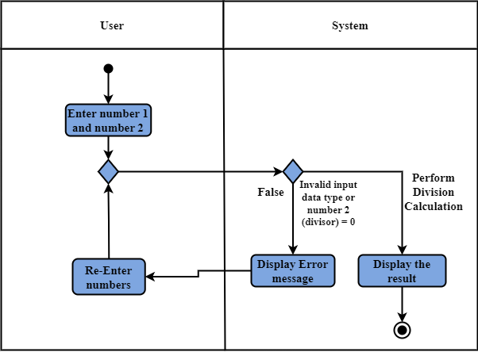

## Division with remainder

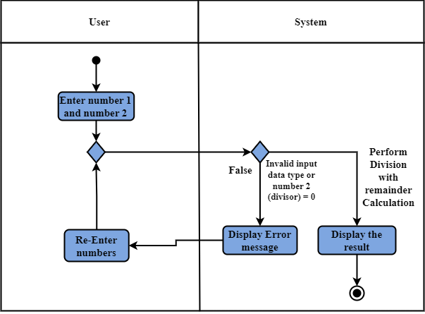

# Appendix A: Glossary

|  |  |
| --- | --- |
| FR | Functional Requirement |
| QA | Quality Attribute |
| UC | Use case |
| BR | Business rule |